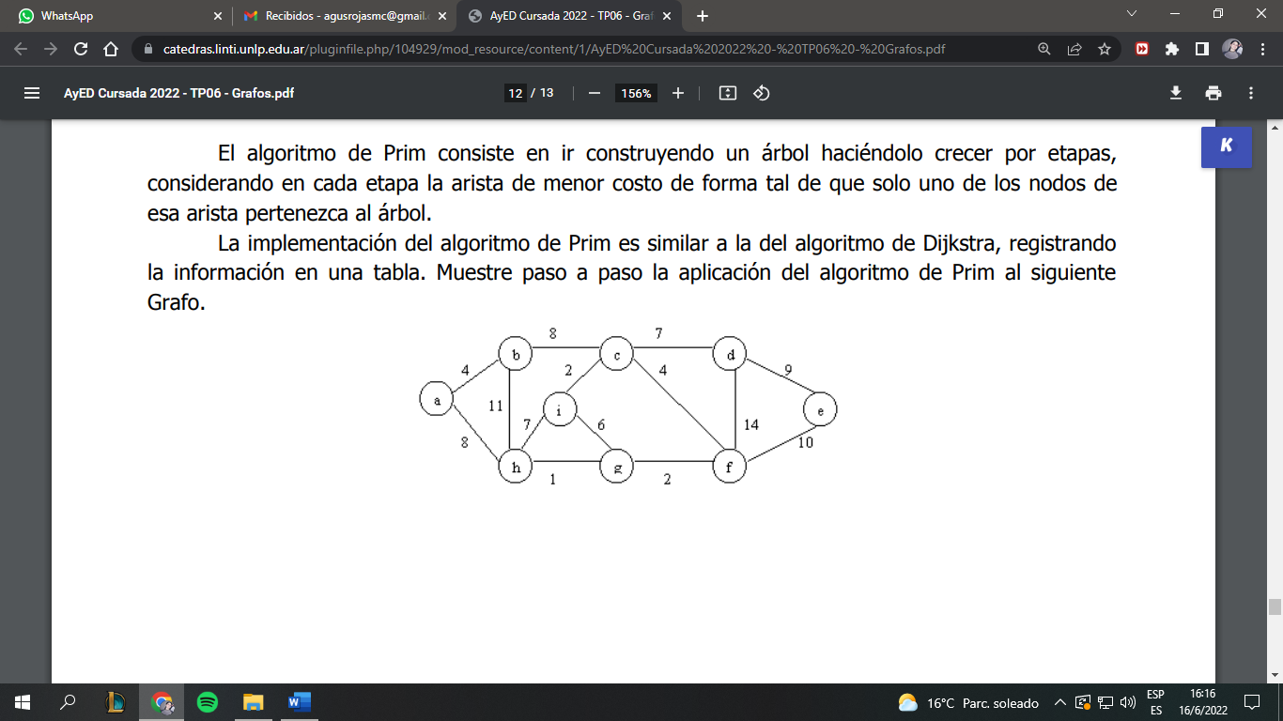

* Tabla Inicial

|  |  |  |  |
| --- | --- | --- | --- |
| V | DV | PV | Conocido |
| A | 0 | 0 | 0 |
| B | ∞ | 0 | 0 |
| C | ∞ | 0 | 0 |
| D | ∞ | 0 | 0 |
| E | ∞ | 0 | 0 |
| F | ∞ | 0 | 0 |
| G | ∞ | 0 | 0 |
| H | ∞ | 0 | 0 |
| I | ∞ | 0 | 0 |

* Selecciono A, lo marco como visitado y actualizo B y H.

|  |  |  |  |
| --- | --- | --- | --- |
| V | DV | PV | Conocido |
| A | 0 | 0 | 1 |
| B | 4 | 0 | 0 |
| C | ∞ | 0 | 0 |
| D | ∞ | 0 | 0 |
| E | ∞ | 0 | 0 |
| F | ∞ | 0 | 0 |
| G | ∞ | 0 | 0 |
| H | 8 | 0 | 0 |
| I | ∞ | 0 | 0 |

* Selecciono B, lo marco como visitado y actualizo C

|  |  |  |  |
| --- | --- | --- | --- |
| V | DV | PV | Conocido |
| A | 0 | 0 | 1 |
| B | 4 | A | 1 |
| C | 8 | B | 0 |
| D | ∞ | 0 | 0 |
| E | ∞ | 0 | 0 |
| F | ∞ | 0 | 0 |
| G | ∞ | 0 | 0 |
| H | 8 | A | 0 |
| I | ∞ | 0 | 0 |

* Selecciono H, lo marco como visitado y actualizo G e I.

|  |  |  |  |
| --- | --- | --- | --- |
| V | DV | PV | Conocido |
| A | 0 | 0 | 1 |
| B | 4 | A | 1 |
| C | 8 | B | 0 |
| D | ∞ | 0 | 0 |
| E | ∞ | 0 | 0 |
| F | ∞ | 0 | 0 |
| G | 1 | H | 0 |
| H | 8 | A | 1 |
| I | 7 | H | 0 |

* Selecciono G, lo marco como visitado y actualizo F e I

|  |  |  |  |
| --- | --- | --- | --- |
| V | DV | PV | Conocido |
| A | 0 | 0 | 1 |
| B | 4 | A | 1 |
| C | 8 | B | 0 |
| D | ∞ | 0 | 0 |
| E | ∞ | 0 | 0 |
| F | 2 | G | 0 |
| G | 1 | H | 1 |
| H | 8 | A | 1 |
| I | 6 | G | 0 |

* Selecciono F, lo marco como visitado y actualizo C, D y E.

|  |  |  |  |
| --- | --- | --- | --- |
| V | DV | PV | Conocido |
| A | 0 | 0 | 1 |
| B | 4 | A | 1 |
| C | 4 | F | 0 |
| D | 14 | F | 0 |
| E | 10 | F | 0 |
| F | 2 | G | 1 |
| G | 1 | H | 1 |
| H | 8 | A | 1 |
| I | 6 | G | 0 |

* Selecciono C, lo marco como visitado y actualizo I, D y E.

|  |  |  |  |
| --- | --- | --- | --- |
| V | DV | PV | Conocido |
| A | 0 | 0 | 1 |
| B | 4 | A | 1 |
| C | 4 | F | 1 |
| D | 7 | C | 0 |
| E | 10 | F | 0 |
| F | 2 | G | 1 |
| G | 1 | H | 1 |
| H | 8 | A | 1 |
| I | 2 | C | 0 |

* Selecciono I, lo marco como visitado y no actualizo nada

|  |  |  |  |
| --- | --- | --- | --- |
| V | DV | PV | Conocido |
| A | 0 | 0 | 1 |
| B | 4 | A | 1 |
| C | 4 | F | 1 |
| D | 7 | C | 0 |
| E | 10 | F | 0 |
| F | 2 | G | 1 |
| G | 1 | H | 1 |
| H | 8 | A | 1 |
| I | 2 | C | 1 |

* Selecciono D, lo marco como visitado y actualizo E

|  |  |  |  |
| --- | --- | --- | --- |
| V | DV | PV | Conocido |
| A | 0 | 0 | 1 |
| B | 4 | A | 1 |
| C | 4 | F | 1 |
| D | 7 | C | 1 |
| E | 9 | D | 0 |
| F | 2 | G | 1 |
| G | 1 | H | 1 |
| H | 8 | A | 1 |
| I | 2 | C | 1 |

* Selecciono e, lo marco como visitado y no actualizo nada

|  |  |  |  |
| --- | --- | --- | --- |
| V | DV | PV | Conocido |
| A | 0 | 0 | 1 |
| B | 4 | A | 1 |
| C | 4 | F | 1 |
| D | 7 | C | 1 |
| E | 9 | D | 1 |
| F | 2 | G | 1 |
| G | 1 | H | 1 |
| H | 8 | A | 1 |
| I | 2 | C | 1 |